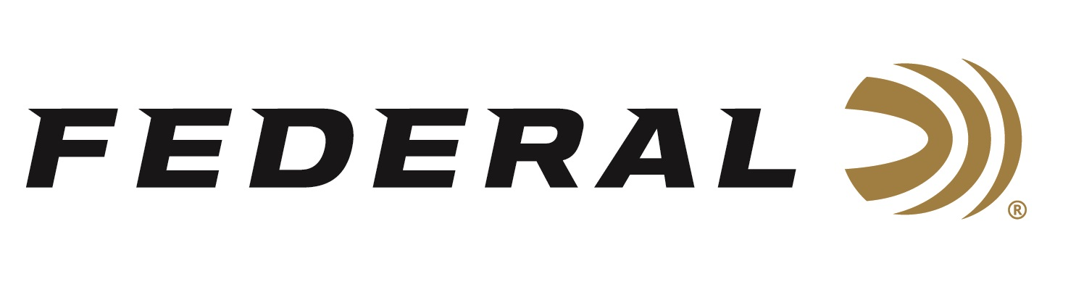

FOR IMMEDIATE RELEASE

World Champion Vincent Hancock featured on Federal Ammunition’s “It’s Federal Season” Podcast

ANOKA, Minnesota – March 5, 2020 – It is more likely to be struck by lightning than to win a gold medal at the Olympic games. Now imagine you’ve accomplished that feat twice. A special edition of “It’s Federal Season” podcast welcomes four-time World Champion and two-time Olympic Men’s Skeet champion Vincent Hancock to the microphone for an in-depth discussion on becoming one of the sports all-time best. This episode will be live for downloading on March 5, 2020 during the second qualifying match.

Episode No. 4 - Raise the Flag
https://www.federalpremium.com/podcast.html

“Vincent has a great story and tells it masterfully,” says Jason Vanderbrink, President of Federal Ammunition. Learn about his story, his practice regimen, and the process of competing for a spot on the Olympic team. “Vincent is a great ambassador for Federal,” says Vanderbrink. “We and our employees are proud to support him and USA Shooting as they prepare for another Olympic games.”

Before signing off, find out what promotions are available for consumers and where consumers can meet with our ammunition team in the near future to talk all things ammunition. Look for more information at www.federalpremium.com or where you find your favorite podcasts.

Press Release Contact: JJ Reich
Senior Communications Manager - Firearms and Ammunition
E-mail: VistaPressroom@VistaOutdoor.com

About Federal Ammunition
Federal, headquartered in Anoka, MN, is a brand of Vista Outdoor Inc., an outdoor sports and recreation company. From humble beginnings nestled among the lakes and woods of Minnesota, Federal Ammunition has evolved into one of the world's largest producers of sporting ammunition. Beginning in 1922, founding president, Charles L. Horn, paved the way for our success. Today, Federal carries on Horn's vision for quality products and service with the next generation of outdoorsmen and women. We maintain our position as experts in the science of ammunition production. Every day we manufacture products to enhance our customers' shooting experience while partnering with the conservation organizations that protect and support our outdoor heritage. We offer thousands of options in our Federal Premium and Federal® lines-it's what makes us the most complete ammunition company in the business and provides our customers with a choice no matter their pursuit.

